Instructions for PrEPARING THE FULL PAPER FOR
IS-AGTG 2011

FIRST AUTHOR
University Department, University Name, Address
City, State ZIP/Zone, Country

SECOND AUTHOR
Group, Laboratory, Address
City, State ZIP/Zone, Country

This is where the abstract should be placed. It should consist of one paragraph giving a concise summary of the material in the article below. Replace the title, authors, and addresses with your own title, authors, and addresses.

IMPORTANT SUBMISSION INFORMATION

All papers must be written in English. SI-units should be used. The paper should not exceed eight (08) pages. Manuscripts must be uploaded to http://www.is-agtg.com/paper_sub.html before 15 May 2011 in MS WORD format for inclusion in the conference proceedings.

GUIDELINES

Preparing the manuscript in MS-Word
You can delete our sample text and replace it with the text of your own contribution to the proceedings. However we recommend that you keep an initial version of this file for reference.

Please set your page size as standard A4. The top and bottom margins should be set at 5 cm each; right and left margins at 3.5 cm each. The header and footer should be set at 3 cm each.. The text should be set in 10 pt Times New Roman with single-line spacing. Type the title of the paper in 12 pt Times New Roman boldface, all upper case. Headers should be in 10 pt Times New Roman boldface, upper case. Sub-headings in 10 pt Times New Roman boldface, lower case. If there is a 3rd level sub-heading, then it should be 10 pt Times New Roman italics, lower case.

Authors’ names are set in 10 pt Times New Roman, upper case. Addresses are in 10 pt Times New Roman italics. Figure and table captions also should be in 10 pt, lower case.

Each new paragraph should be preceded by a single-line spacing. Do not indent paragraphs. All paragraphs must be fully justified.

Headings, equations, and citations
Please preserve the style of the headings, text font and line spacing in order to provide a uniform style for the proceedings volume.

Equations should be aligned to left margin and numbered consecutively, as in Eq. (1). Equation numbers should be aligned to right margin. An alternative method is given in Eq. (2) for long sets of equations where only one referencing equation number is required.

The papers in the reference list must be cited in the text. In the text, the citation should appear in square brackets “[ ]”, as in, for example James et al. [1].

Tables
The tables are designed to have a uniform style throughout the paper. It does not matter how you choose to place the inner lines of the table, but we would prefer the border lines to be of the style shown in Table 1. For the inner lines of the table, it looks better if they are kept to a minimum. The caption heading for a table should be placed at the top of the table. Tables should preferably be located at the top or bottom of the page where they are first cited.

Table 1. First five normalized natural frequencies of a clamped beam with internal hinge at 4 different locations.

 | A = 0.56 | B = 0.69 | C = 0.75 | D = 0.100
AB₁ | 14.0640 | 18.5620 | 22.0817 | 18.90732
AC₂ | 61.6728 | 44.7844 | 44.5884 | 60.17496
AD₃ | 88.1380 | 118.1564 | 101.2240 | 120.72693
DB₄ | 199.8594 | 173.1269 | 194.4907 | 188.75258
DA₅ | 246.7889 | 255.9483 | 284.6633 | 262.24264

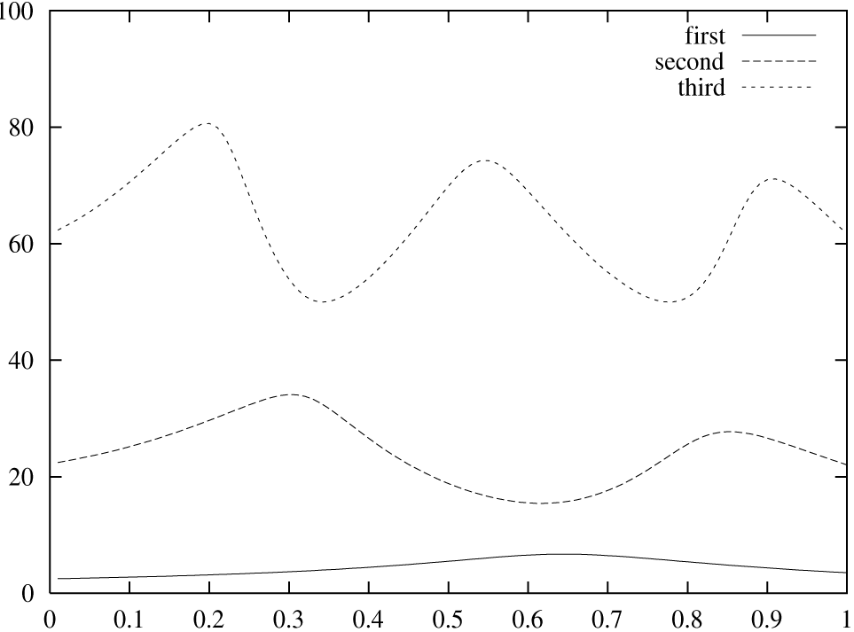

Figure 1. First 3 normalized frequencies versus release location for clamped simply supported beam with internal slide release.

Figures or illustrations
It is best to embed the figures in the text where they are first cited and to locate them at the top or bottom of the page, e.g. see Figure 1. Please ensure that all labels in the figures are legible regardless of whether they are drawn electronically or manually. The caption heading for a figure should be placed below the figure.

Authors are advised to prepare their figures in black and white. Please prepare the figures in high resolution (300 dpi) for half-tone illustrations or images. Half-tone pictures must be sharp enough for reproduction, otherwise they will be rejected.

Limitations on the placement of tables, equations and figures
Very large figures and tables should be placed on a page by themselves. Note the use of third level heading (10 pt Times New Roman, italics).

Acknowledgments, appendices, and references
If you wish to acknowledge funding bodies etc., the acknowledgments may be placed in a separate section at the end of the text, before the Appendices. It is preferable not to have Appendices in a brief article, but if more than one Appendix is necessary then set headings as Appendix A, Appendix B etc.

REFERENCES

- James J., Jones B. and Brown J., “The title of the book”, 1st edition, Publisher, (2001).
- James J., Jones B and Brown J., “The title of the conference paper”, Proc. Conference title, where it took place, Vol. 1, (2001), pp 1-11.
- James J., Jones B. and Brown J., “The title of the journal paper”, Journal Name, Vol. 1, No. 1, (2001), pp 1-11.

